


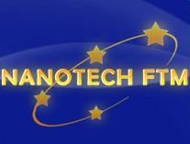

Faculty of Technology and Metallurgy University of Belgrade -
Nanotechnology and Functional Materials Centre
Serbia
is organizing

International Workshop
on
Processing of Nanostructured Ceramics, Polymers, and Composites

Belgrade, Serbia, November 29 - 30, 2010

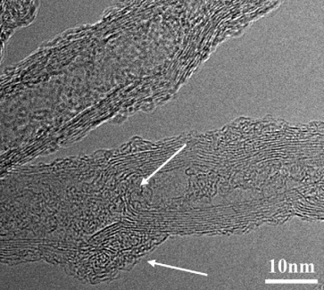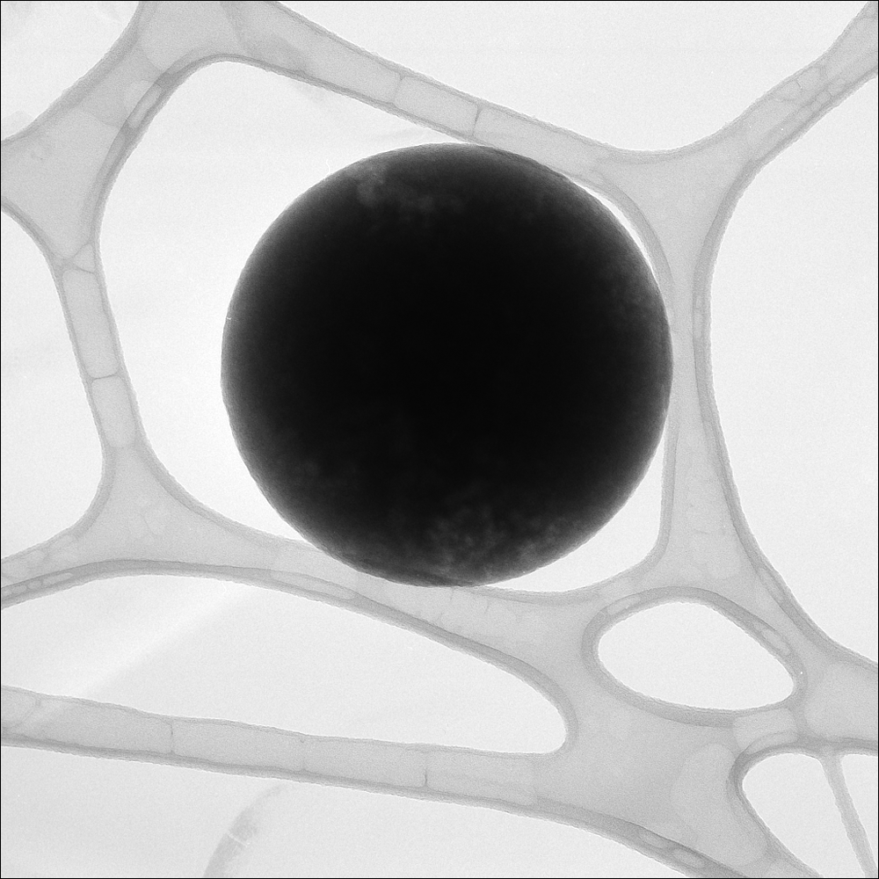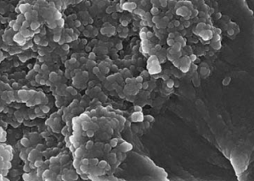

The Workshop aims to present current advances in processing of nanomaterials. It will be organized as oral sessions with invited speakers from the international as well as local academic, scientific, and industrial communities, a poster session in which young researchers will have the opportunity to presents their research, and a round table “Nanotechnology today – where is it going?” that will initiate discussions on fundamental issues as well as on various of potentials for applications of nanotechnology today.
The Workshop is organized as a part of the FP7 project Reinforcing of Nanotechnology and Functional Materials Centre (No: 245916).

Invited speakers:

Lars Berglund, Professor, School of Chemical Science and Engineering KTH - Royal Institute of Technology, Stockholm, Sweden
Aldo R. Boccaccini, Professor, Head, Institute of Biomaterials, Department of Materials Science and Engineering, University of Erlangen-Nuremberg, Germany
Rodrigo Moreno Botella, Professor, Instituto de ceramica y vidrio SCIC, Madrid, Spain
Miroslav Dramicanin, Professor, Institute of Vinca, University of Belgrade, Belgrade, Serbia
Paolo Ermanni, Professor, ETH Zurich, Institute of Mechanical Systems (IMES), Zurich, Switzerland
Jean-François Gérard, Professor, IMP@INSA-Site INSA Lyon, France
Djordje Janackovic, Professor, Nanotechnology and Functional Materials Centre, Faculty of Technology and Metallurgy University of Belgrade, Belgrade, Serbia
Josè M. Kenny, Professor, Director, Materials Science and Technology Laboratory, University of Perugia, Italy
Ion Mihailescu, Professor, National Institute for Laser, Plasma, and Radiation Physics, Buchurest, Romania
Jovan Nedeljkovic, Directoir, Institute of Vinca, University of Belgrade, Belgrade, Serbia
Ersen Ovidiu, Professor, Institut de Physique et Chimie des Materiaux de Strasbourg, Strasbourg, France
Eriks Palcevskis, Senior Researcher, Institute of Inorganic Chemistry, Riga Technical University, Riga, Latvia
Dominique Perreux, Professor, MaHyTec Ltd, University of Franche-Comté, Dole, France
Zoran Popovic, Professor, Institute of Physiscs, University of Belgrade, Belgrade, Serbia
Velimir Radmilovic, Professor, Nanotechnology and Functional Materials Centre, Faculty of Technology and Metallurgy University of Belgrade, Belgrade, Serbia
Vladimir Srdic, Professor, Faculty of Technology, University of Novi Sad, Novi Sad, Serbia
Luigi Torre, Professor, Facoltà di Ingegneria dell’Università degli Studi di Perugia, Italy
Dragan Uskokovic, Professor, Director, Institute of Technical Sciences of Serbian Academy of Sciences and Arts, Belgrade, Serbia
Petar Uskokovic, Professor, Nanotechnology and Functional Materials Centre, Faculty of Technology and Metallurgy University of Belgrade, Belgrade, Serbia
Luca Valentini, Professor, Facoltà di Ingegneria dell’Università degli Studi di Perugia, Italy

Call for abstracts for poster presentations: deadline – November 10, 2010-10-11
Please send abstracts formatted according to the template to: Sandra Glisic: sglisic@tmf.bg.ac.rs

Program Committee:

Petar Uskokovic, Professor, University of Belgrade (Chair)
Josè M. Kenny, Professor, University of Perugia
Ion Mihailescu, Professor, National Institute for Laser, Plasma, and Radiation Physics, Buchurest
Jacques Werckmann, Senior Scientist, Institut de Physique et Chimie des Materiaux de Strasbourg
Eriks Palcevskis, Senior Scientist, Riga Technical University
Dominique Perreaux, Professor, University of Franche-Comté, MaHyTec Ltd
Djordje Janackovic, Professor, University of Belgrade
Velimir Radmilovic, Professor, University of Belgrade

Organizing Committee:

Bojana Obradovic (Chair, University of Belgrade)
Djordje Janackovic (University of Belgrade)
Petar Uskokovic (University of Belgrade)
Aleksandar Orlovic (University of Belgrade)
Sandra Glisic (University of Belgrade)
Goran Vukovic (University of Belgrade)

Contact person:

Prof. Bojana Obradovic (bojana@tmf.bg.ac.rs)
Chair of the Organizing Committee
Vice-Dean
Faculty of Technology and Metallurgy, University of Belgrade

Program

Monday, November 29
9.00 – 9.30 Opening ceremony
9.30 – 13.00 Invited talks
13.00 – 14.00 Lunch break
14.00 – 14.30 Poster session
14.30 – 16.00 Invited talks
16.00 – 17.30 Round table: “Nanotechnology today – where is it going?”,
17.30 – 18.30 Cocktail, poster session

Tuesday, November 30
9.00 – 10.30 Invited talks
10.30 – 11.00 Poster session
11.00 – 12.30 Invited talks
12.30 – 13.00 Concluding remarks and closing ceremony

