


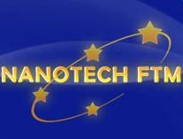

Faculty of Technology and Metallurgy University of Belgrade -
Nanotechnology and Functional Materials Centre
Serbia
is organizing

International Workshop
on
Processing of Nanostructured Ceramics, Polymers, and Composites

Belgrade, Serbia, November 29 - 30, 2010

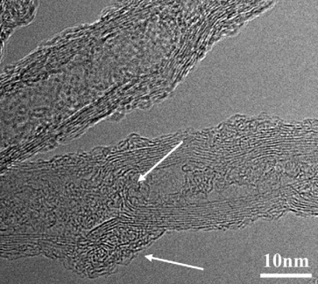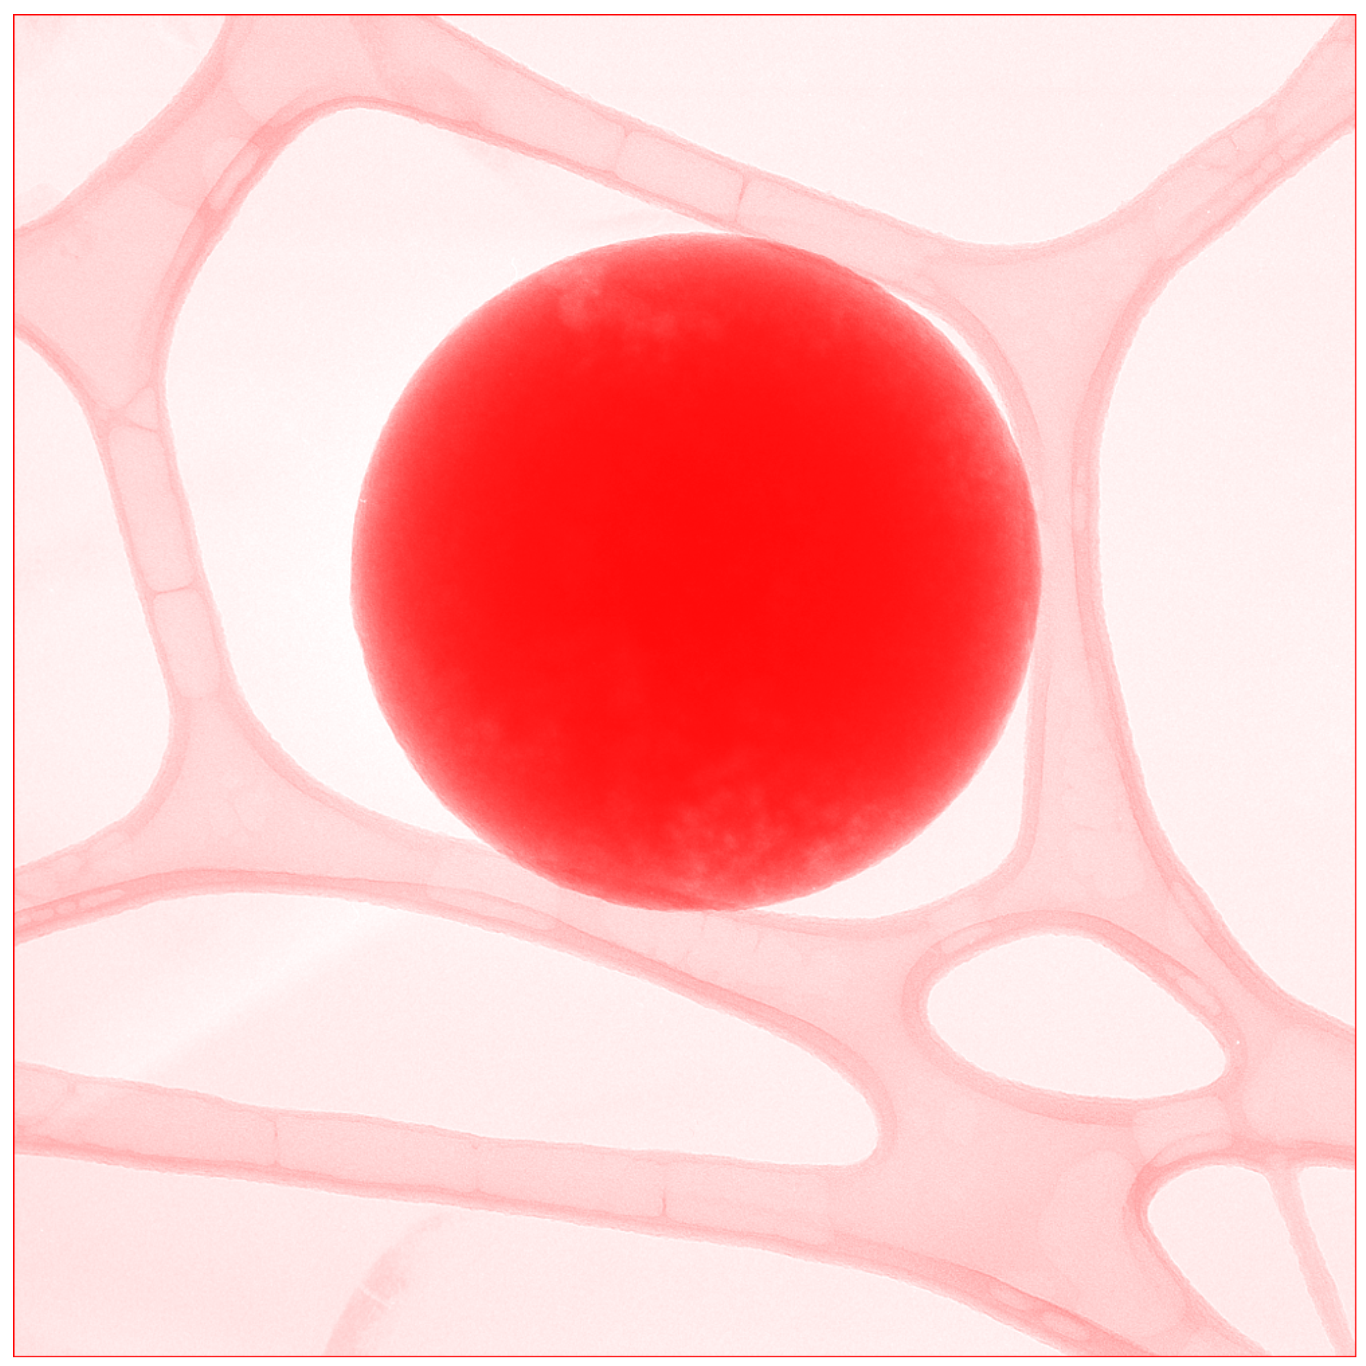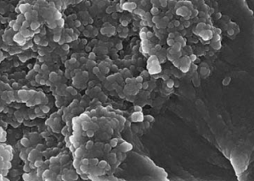

The Workshop aims to present current advances in processing of nanomaterials. It will be organized as oral sessions with invited speakers from the international as well as local academic, scientific, and industrial communities, a poster session in which young researchers will have the opportunity to present their research, and a round table “Nanotechnology today – where is it going?” that will initiate discussions on fundamental issues as well as on various potentials for applications of nanotechnology today.
The Workshop is organized as part of the FP7 project Reinforcing of Nanotechnology and Functional Materials Centre (No: 245916).

Invited speakers:

Berglund Lars, School of Chemical Science and Engineering KTH - Royal Institute of Technology, Stockholm, Sweden
Boccaccini Aldo R., Institute of Biomaterials, Department of Materials Science and Engineering, University of Erlangen-Nuremberg, Germany
Dramicanin Miroslav, Institute of Vinca, University of Belgrade, Belgrade, Serbia
Ermanni Paolo, ETH Zurich, Institute of Mechanical Systems (IMES), Zurich, Switzerland
Ersen Ovidiu, Institut de Physique et Chimie des Materiaux de Strasbourg, Strasbourg, France
Gérard Jean-François, IMP@INSA-Site INSA Lyon, France
Janackovic Djordje, Faculty of Technology and Metallurgy University of Belgrade, Belgrade, Serbia
Kenny Josè M., Materials Science and Technology Laboratory, University of Perugia, Italy
Mihailescu Ion, National Institute for Laser, Plasma, and Radiation Physics, Buchurest, Romania
Moreno Rodrigo, Instituto de Ceramica y Vidrio SCIC, Madrid, Spain
Nedeljkovic Jovan, Institute of Vinca, University of Belgrade, Belgrade, Serbia
Palcevskis Eriks, Institute of Inorganic Chemistry, Riga Technical University, Riga, Latvia
Perreux Dominique, MaHyTec Ltd, University of Franche-Comté, Dole, France
Popovic Ivanka, Faculty of Technology and Metallurgy University of Belgrade, Belgrade, Serbia
Popovic Zoran, Institute of Physiscs, University of Belgrade, Belgrade, Serbia
Radmilovic Velimir, Faculty of Technology and Metallurgy University of Belgrade, Belgrade, Serbia
Srdic Vladimir, Faculty of Technology, University of Novi Sad, Novi Sad, Serbia
Torre Luigi, Facoltà di Ingegneria dell’Università degli Studi di Perugia, Italy
Uskokovic Dragan, Institute of Technical Sciences of Serbian Academy of Sciences and Arts, Belgrade, Serbia
Uskokovic Petar, Faculty of Technology and Metallurgy University of Belgrade, Belgrade, Serbia
Valentini Luca, Materials Science and Technology Laboratory, University of Perugia, Italy

Call for abstracts for poster presentations: deadline – November 15, 2010
Please send abstracts formatted according to the template to email address: nanotech@tmf.bg.ac.rs

Contact person:

Prof. Bojana Obradovic (bojana@tmf.bg.ac.rs)
Chair of the Organizing Committee
Vice-Dean
Faculty of Technology and Metallurgy, University of Belgrade

Program Committee:
Chair: Uskokovic Petar, University of Belgrade
Members:
Aleksic Radoslav, University of Belgrade
Janackovic Djordje, University of Belgrade
Kenny Josè M., University of Perugia
Mihailescu Ion, National Institute for Laser, Plasma, and Radiation Physics, Buchurest
Palcevskis Eriks, Riga Technical University
Perreux Dominique, University of Franche-Comté, MaHyTec Ltd
Popovic Ivanka, University of Belgrade
Radmilovic Velimir, University of Belgrade
Werckmann Jacques, Institut de Physique et Chimie des Materiaux de Strasbourg

Organizing Committee:
Chair: Obradovic Bojana, University of Belgrade
Members:
Orlovic Aleksandar, University of Belgrade
Petrovic Rada, University of Belgrade
Radojevic Vesna, University of Belgrade
Stamenkovic Ivan, University of Belgrade

Program

Monday, November 29
9.00 – 9.30 Opening session (Ivanka Popovic, Djordje Janackovic, Petar Uskokovic)
9.30 – 13.00 Invited talks
13.00 – 14.00 Lunch break
14.00 – 14.30 Poster session
14.30 – 16.00 Invited talks
16.00 – 17.30 Round table: “Nanotechnology today – where is it going?”
17.30 – 18.30 Cocktail, poster session

Tuesday, November 30
9.00 – 10.30 Invited talks
10.30 – 11.00 Poster session
11.00 – 12.30 Invited talks
12.30 – 13.00 Concluding remarks and closing ceremony

Template for abstracts:

Page setup: B5(ISO): 17,6x25 cm
All margins: 2,54 cm

Title (Font 12, bold, Title Case)

Authors (font 10, bold, name initial. surname)

Affiliation (font 10, italic, Institution, town, country)

Text (font 10) – up to 200 words

